ПЕРВЫЙ УРОВЕНЬ.

| **Test Case ID** | | BU_001 | **Test Case Description** | | Verify that login by phone number | | | | | |
| --- | --- | --- | --- | --- | --- | --- | --- | --- | --- | --- |
| **Created By** | | Tetiana B | **Reviewed By** | |  | | **Version** | | 2.1 | |
|  |  |  |  |  |  |  |  |  |  |  |
| **QA Tester’s Log** | |  |  |  |  |  |  |  |  |  |
|  |  |  |  |  |  |  |  |  |  |  |
| **Tester's Name** | | Tetiana B | **Date Tested** | | February 20, 2023 | | **Test Case (Pass/Fail/Not Executed)** | | Pass | |
|  |  |  |  |  |  |  |  |  |  |  |
| **S #** | **Prerequisites:** | | |  | **S #** | **Test Data** | | | | |
| 1 | Access to Chrome Browser | | |  | 1 | Pass = Test | | | | |
| 2 | Open https://automoto.ua/uk/ | | |  | 2 | Pass = Test | | | | |
| 3 | Click the button `вход` in the header | | |  | 3 | Номер телефона = 0509202778 | | | | |
| 4 | Enter the send code | | |  | 4 | Код = 1234 | | | | |
|  |  |  |  |  |  |  |  |  |  |  |
| **Test Scenario** | Check that when you enter the user`s phone number, a confirmation code comes to the phone |  |  |  |  |  |  |  |  |  |
|  |  |  |  |  |  |  |  |  |  |  |
| **Step #** | **Step Details** | | **Expected Results** | | **Pass / Fail / Not executed / Suspended** | | |  |  |  |
|  |  |  |
| 1 | Enter the phone number in the `вход` | | A field for entering the code should appear | | Pass | | |  |  |  |
| 2 | Enter the code you received | | A user logs in to their account | | Pass | | |  |  |  |
| 3 |  | |  | |  | | |  |  |  |
| 4 |  | |  | |  | | |  | | |
|  |  | |  | |  | | |  | | |
|  |  | |  | |  | | |  | | |

| **Test Case ID** | | BU_002 | **Test Case Description** | | Make sure the main logo is clickable | | | | | |
| --- | --- | --- | --- | --- | --- | --- | --- | --- | --- | --- |
| **Created By** | | Tetiana B | **Reviewed By** | |  | | **Version** | | 2.1 | |
|  |  |  |  |  |  |  |  |  |  |  |
| **QA Tester’s Log** | |  |  |  |  |  |  |  |  |  |
|  |  |  |  |  |  |  |  |  |  |  |
| **Tester's Name** | | Tetiana B | **Date Tested** | | February 20, 2023 | | **Test Case (Pass/Fail/Not Executed)** | | Pass | |
|  |  |  |  |  |  |  |  |  |  |  |
| **S #** | **Prerequisites:** | | |  | **S #** | **Test Data** | | | | |
| 1 | Access to Chrome Browser | | |  | 1 | Pass = Test | | | | |
| 2 | Open https://automoto.ua/uk/ | | |  | 2 | Pass = Test | | | | |
| 3 | Click the tab “б/у авто” | | |  | 3 | Pass = Test | | | | |
| 4 | Click on the site logo icon | | |  | 4 | Pass = Test | | | | |
|  |  |  |  |  |  |  |  |  |  |  |
| **Test Scenario** | Make sure that the site logo button is clickable and when you click on it, we return to the home page of the site |  |  |  |  |  |  |  |  |  |
|  |  |  |  |  |  |  |  |  |  |  |
| **Step #** | **Step Details** | | **Expected Results** | | **Pass / Fail / Not executed / Suspended** | | |  |  |  |
|  |  |  |
| 1 | Let's go to the tab “б/у авто” | | The page with cars opens | | Pass | | |  |  |  |
| 2 | Click on the site logo icon | | We return to the home page of the site | | Pass | | |  |  |  |
| 3 |  | |  | |  | | |  |  |  |
| 4 |  | |  | |  | | |  | | |
|  |  | |  | |  | | |  | | |
|  |  | |  | |  | | |  | | |

| **Test Case ID** | | BU_003 | **Test Case Description** | | Make sure that the string “розширений пошук” makes it possible to choose the necessary parameters | | | | | |
| --- | --- | --- | --- | --- | --- | --- | --- | --- | --- | --- |
| **Created By** | | Tetiana B | **Reviewed By** | |  | | **Version** | |  | |
|  |  |  |  |  |  |  |  |  |  |  |
| **QA Tester’s Log** | |  |  |  |  |  |  |  |  |  |
|  |  |  |  |  |  |  |  |  |  |  |
| **Tester's Name** | | Tetiana B | **Date Tested** | | February 20, 2023 | | **Test Case (Pass/Fail/Not Executed)** | |  | |
|  |  |  |  |  |  |  |  |  |  |  |
| **S #** | **Prerequisites:** | | |  | **S #** | **Test Data** | | | | |
| 1 | Access to Chrome Browser | | |  | 1 | Pass = Test | | | | |
| 2 | Open https://automoto.ua/uk/ | | |  | 2 | Pass = Test | | | | |
| 3 | Click on “розширений пошук” | | |  | 3 | Pass = Test | | | | |
| 4 | Select the necessary parameters | | |  | 4 | Pass = Test | | | | |
|  |  |  |  |  |  |  |  |  |  |  |
| **Test Scenario** | Make sure that when you click on “розширений пошук” opens a page for selecting the desired parameters |  |  |  |  |  |  |  |  |  |
|  |  |  |  |  |  |  |  |  |  |  |
| **Step #** | **Step Details** | | **Expected Results** | | **Pass / Fail / Not executed / Suspended** | | |  |  |  |
|  |  |  |
| 1 | Click on “розширений пошук” | | The advanced search page opens | | Pass | | |  |  |  |
| 2 | Select the parameters we need | | It shows us the results of found ads according to our parameters | | Pass | | |  |  |  |
| 3 |  | |  | |  | | |  |  |  |
| 4 |  | |  | |  | | |  | | |
|  |  | |  | |  | | |  | | |
|  |  | |  | |  | | |  | | |

| **Test Case ID** | | BU_004 | **Test Case Description** | | Check the search for car dealerships by car brand | | | | | |
| --- | --- | --- | --- | --- | --- | --- | --- | --- | --- | --- |
| **Created By** | | Tetiana B | **Reviewed By** | |  | | **Version** | |  | |
|  |  |  |  |  |  |  |  |  |  |  |
| **QA Tester’s Log** | |  |  |  |  |  |  |  |  |  |
|  |  |  |  |  |  |  |  |  |  |  |
| **Tester's Name** | | Tetiana B | **Date Tested** | | February 20, 2023 | | **Test Case (Pass/Fail/Not Executed)** | |  | |
|  |  |  |  |  |  |  |  |  |  |  |
| **S #** | **Prerequisites:** | | |  | **S #** | **Test Data** | | | | |
| 1 | Access to Chrome Browser | | |  | 1 | Pass = Test | | | | |
| 2 | Open https://automoto.ua/uk/ | | |  | 2 | Pass = Test | | | | |
| 3 | Click on the tab “Автосалони” | | |  | 3 | Pass = Test | | | | |
| 4 |  | | |  | 4 |  | | | | |
|  |  |  |  |  |  |  |  |  |  |  |
| **Test Scenario** | Make sure there is an option to search for car dealerships by car brand |  |  |  |  |  |  |  |  |  |
|  |  |  |  |  |  |  |  |  |  |  |
| **Step #** | **Step Details** | | **Expected Results** | | **Pass / Fail / Not executed / Suspended** | | |  |  |  |
|  |  |  |
| 1 | Go to the tab “Автосалони” | | The window for entering vehicle data appears | | Pass | | |  |  |  |
| 2 | Choose the desired car brand and region | | We see the names of the found car dealerships | | Pass | | |  |  |  |
| 3 |  | |  | |  | | |  |  |  |
| 4 |  | |  | |  | | |  | | |
|  |  | |  | |  | | |  | | |
|  |  | |  | |  | | |  | | |

ВТОРОЙ УРОВЕНЬ.

Сразу извиняюсь за качество, но я в поезде на мобильном инете

1. (GET) LIST USERS

Request

/api/users?page=2

Response

200

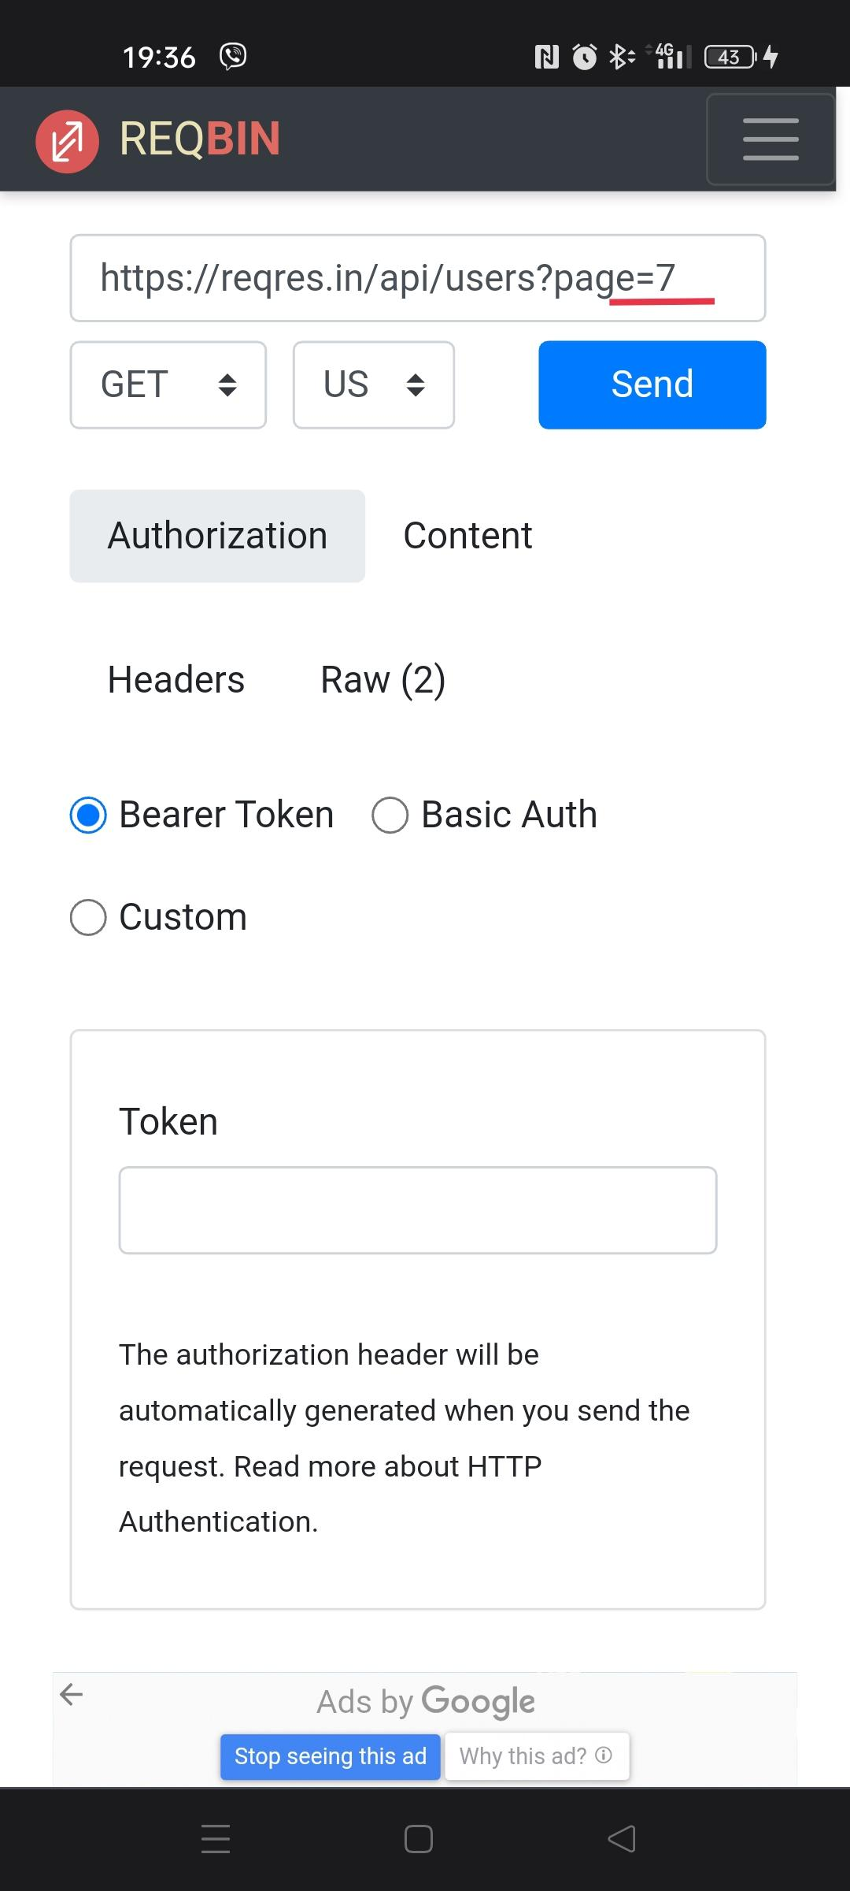

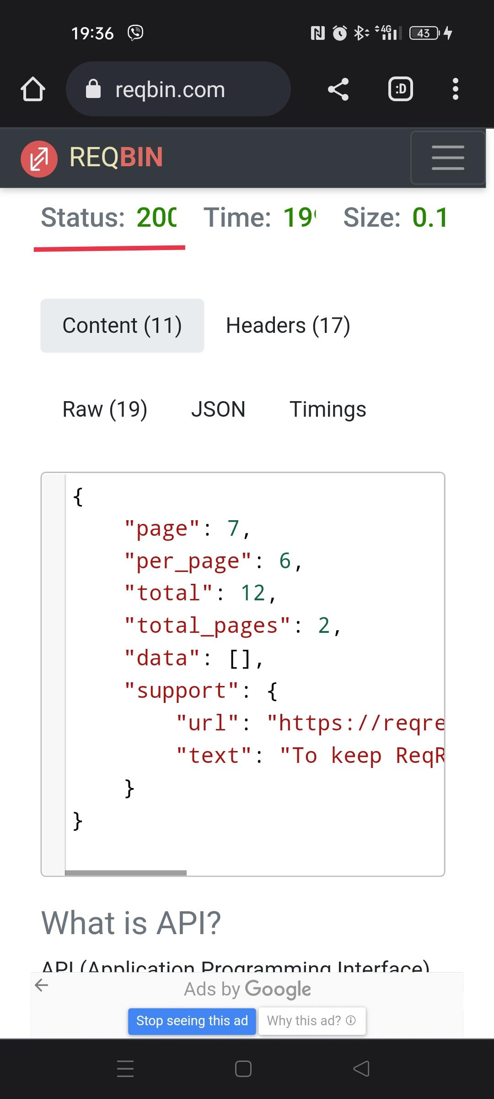

Хоть количество страниц 2, но при вводе 7 всё -равно статус ОК.

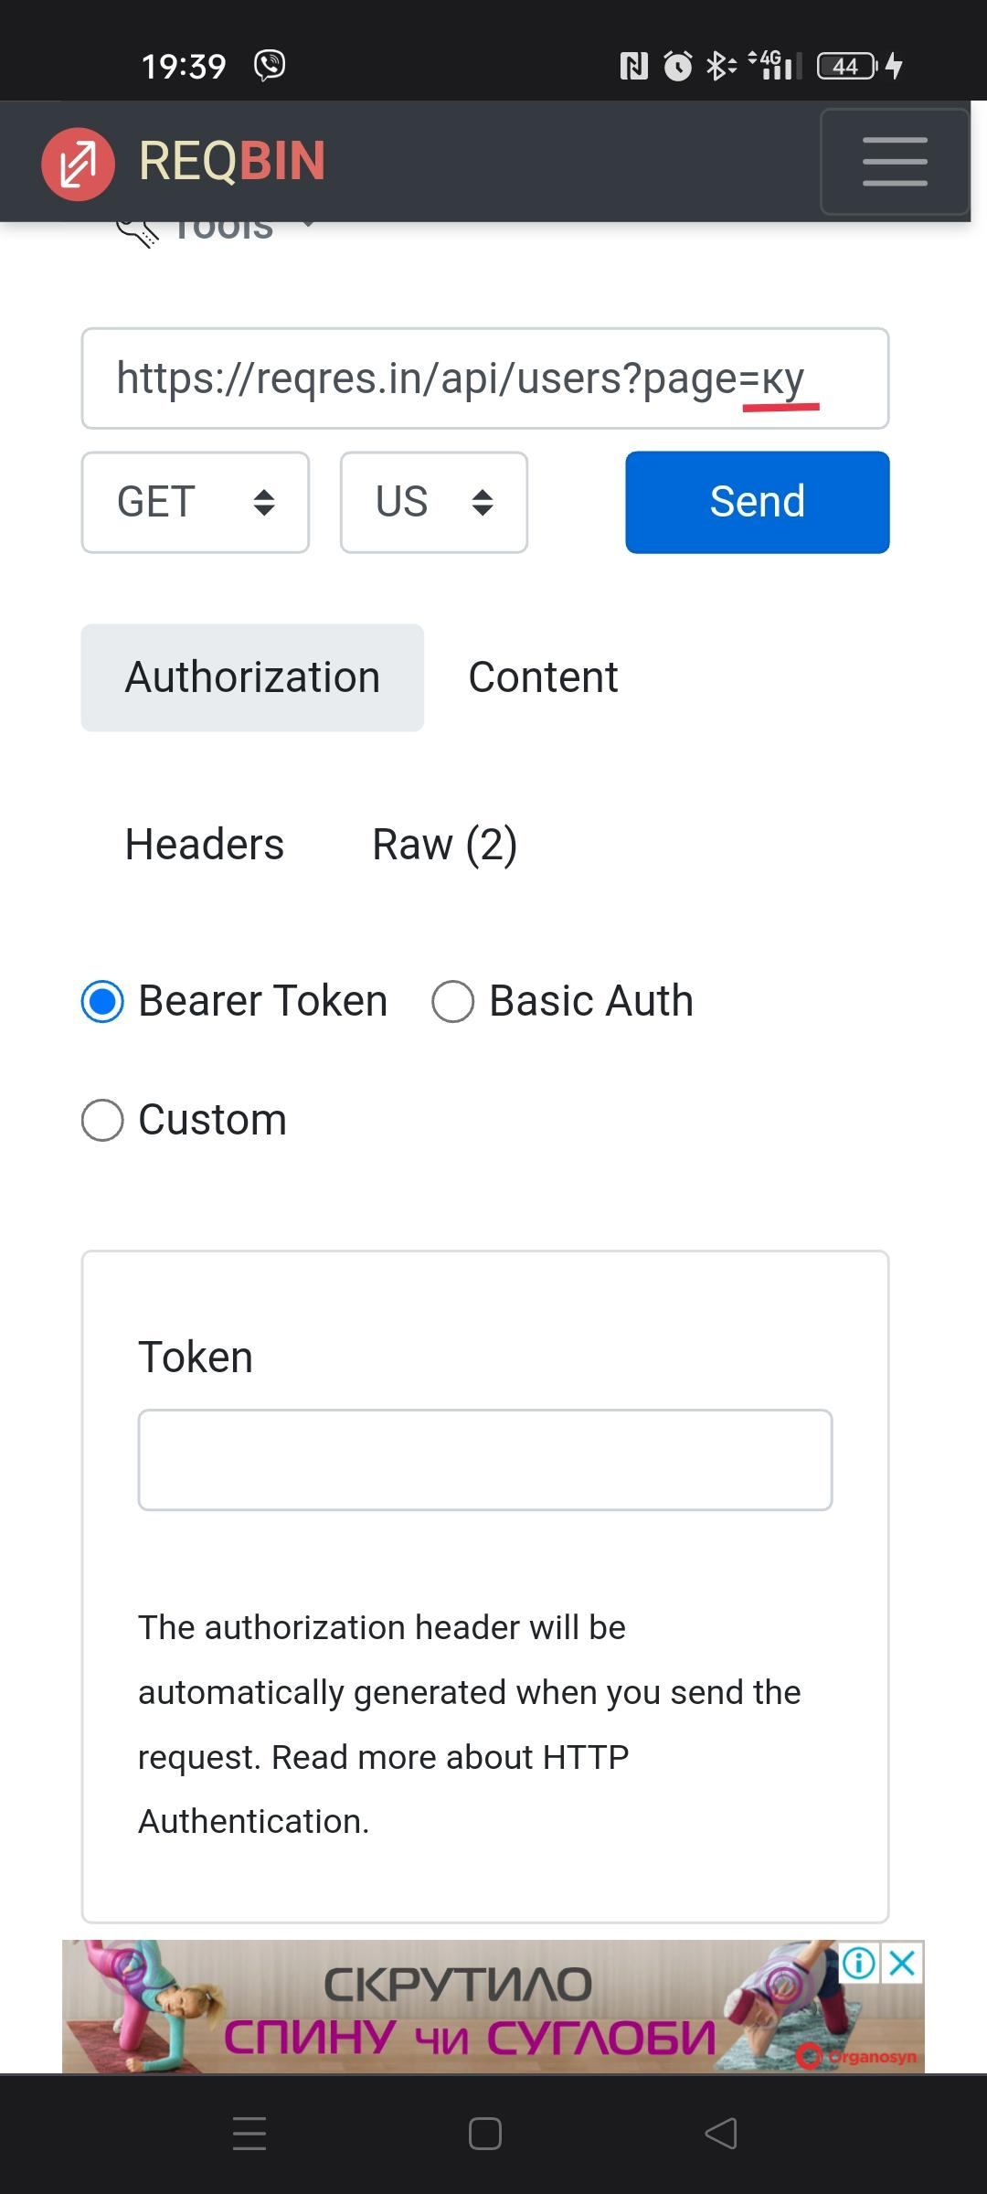

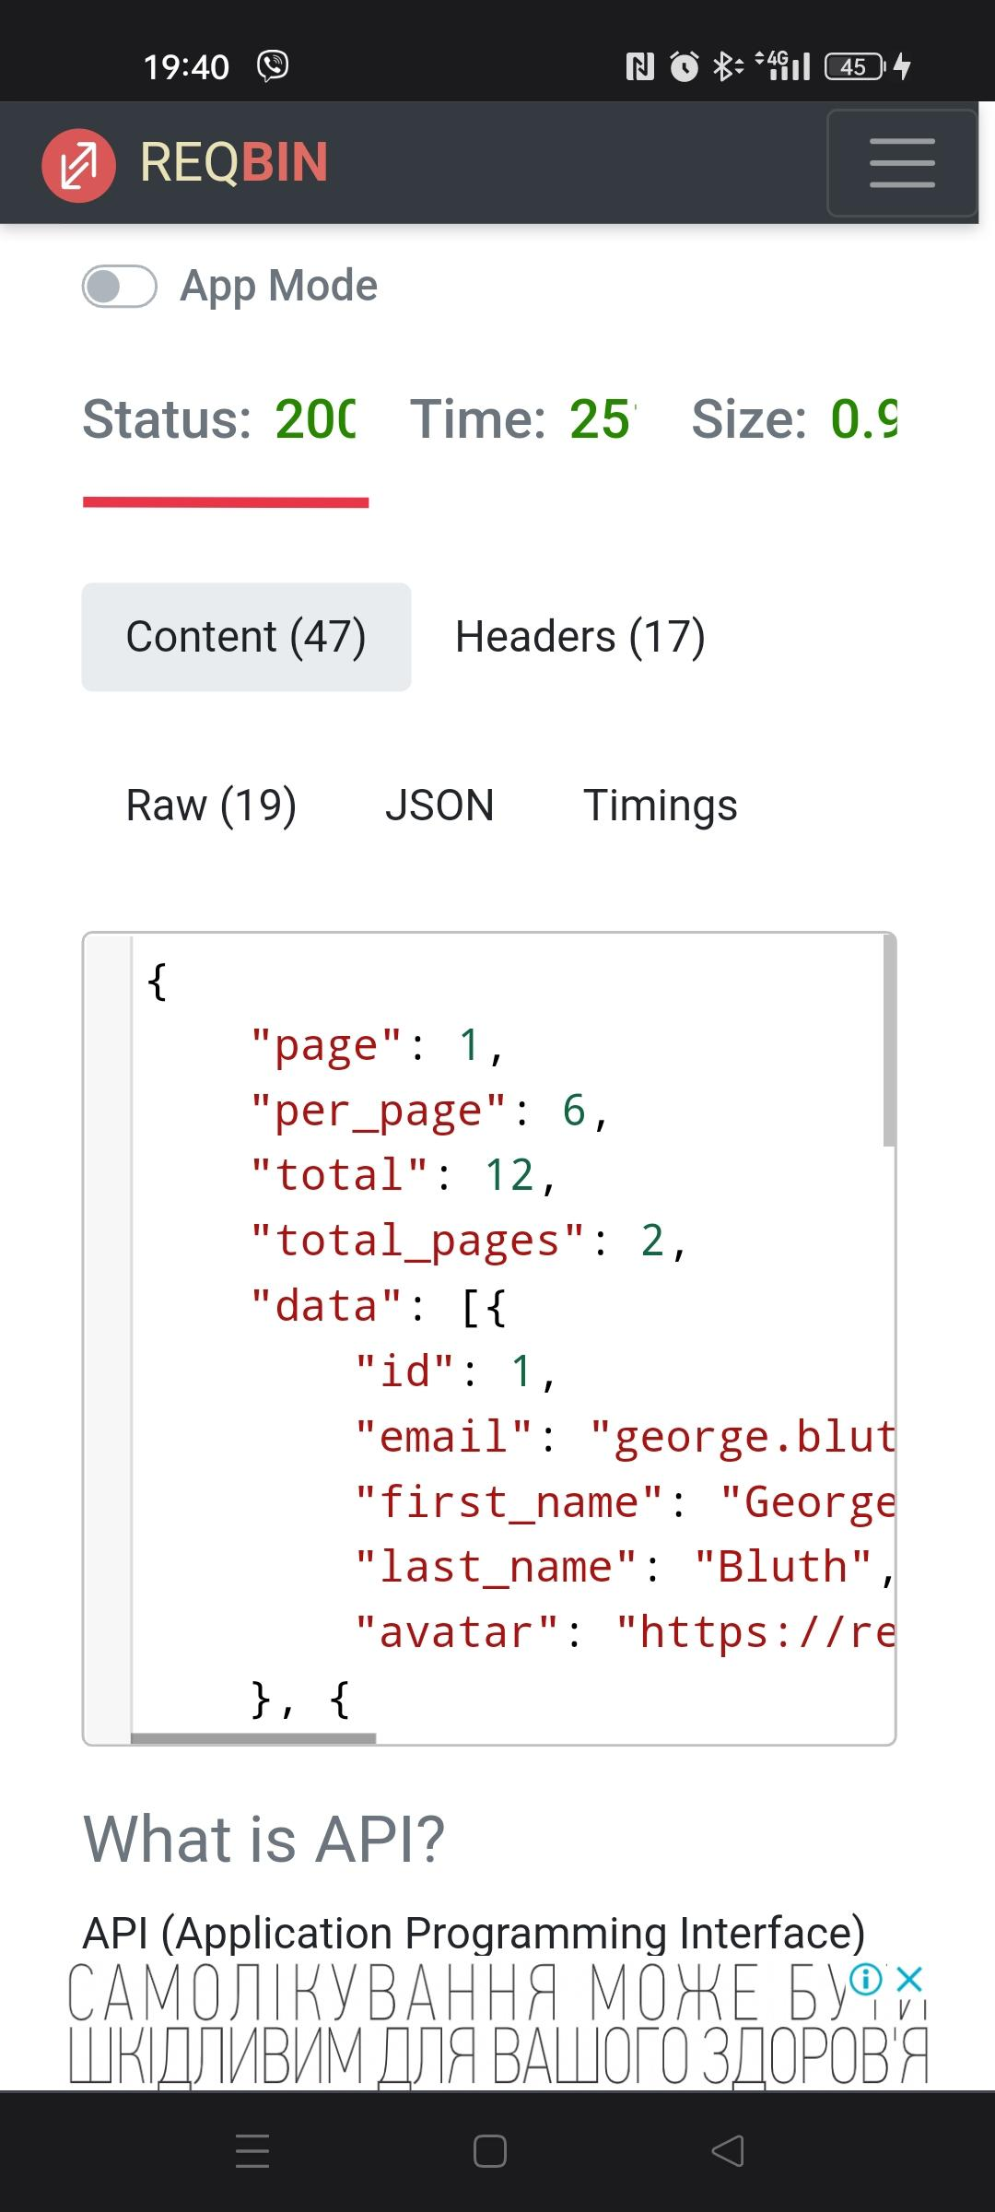

Даже при вводе букв статус ОК.

1. (GET) SINGLE USER

Request

/api/users/23

Response

200

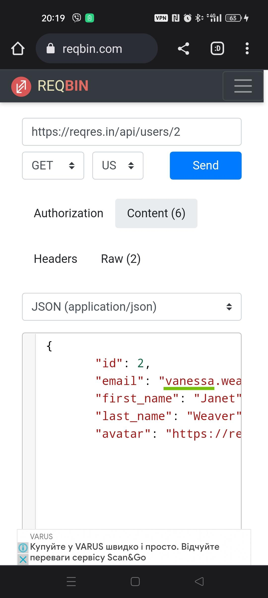

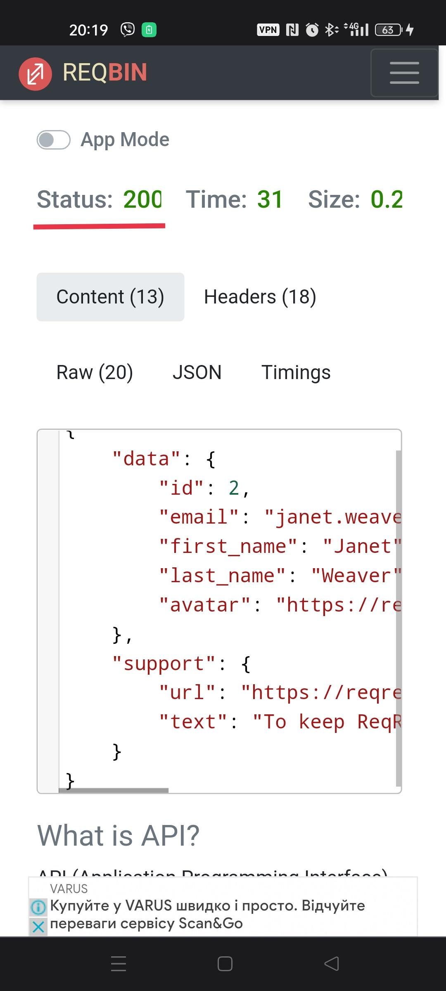

При изменении имени статус остаётся ОК

1. (POST) CREATE

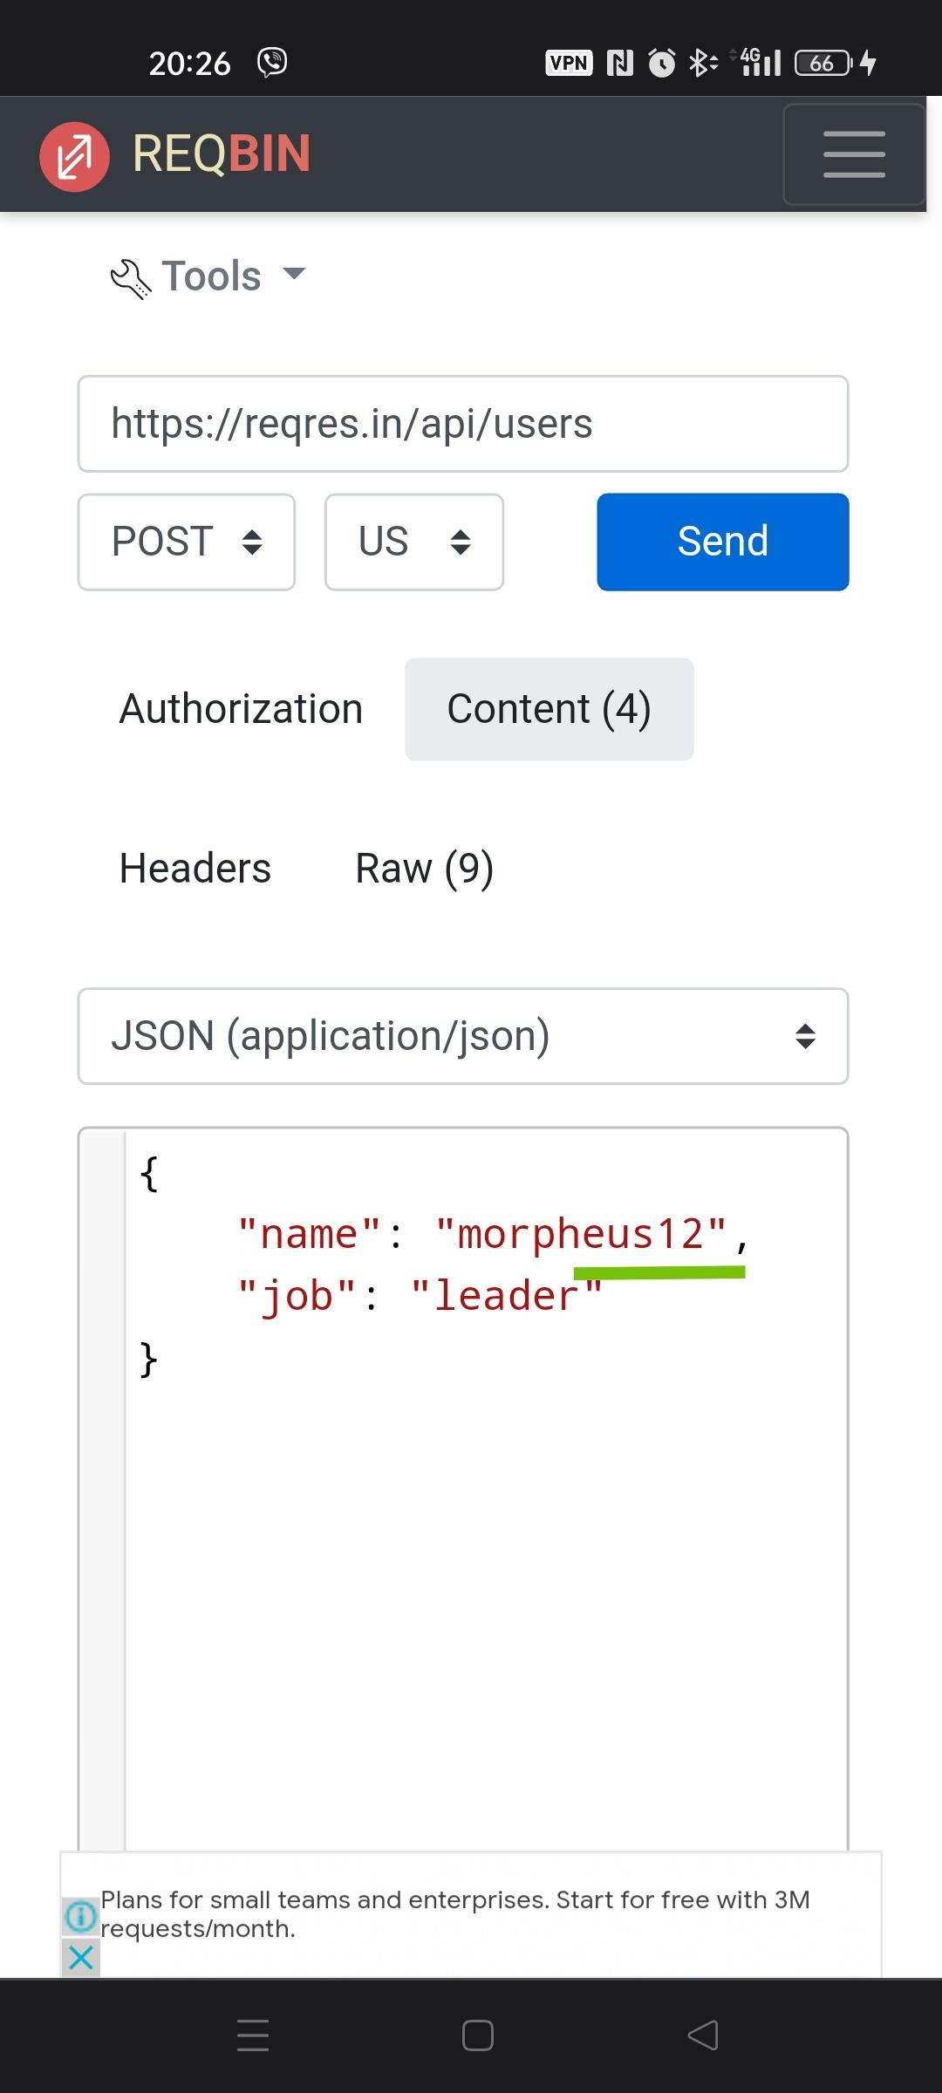

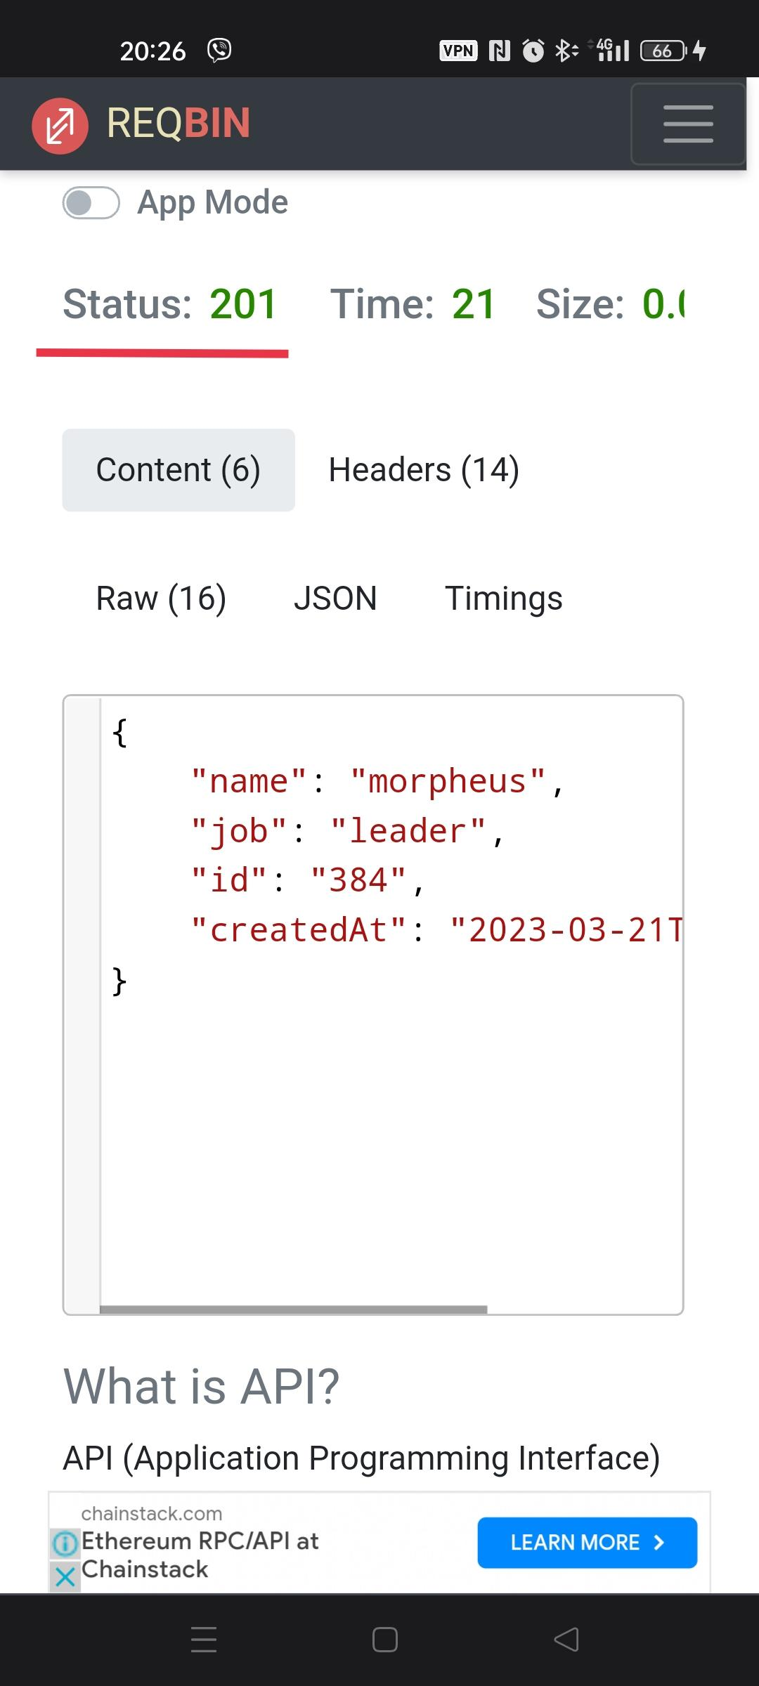

В имени добавлены цифры, но статус не поменялся.

1. UPDATE (PUT)

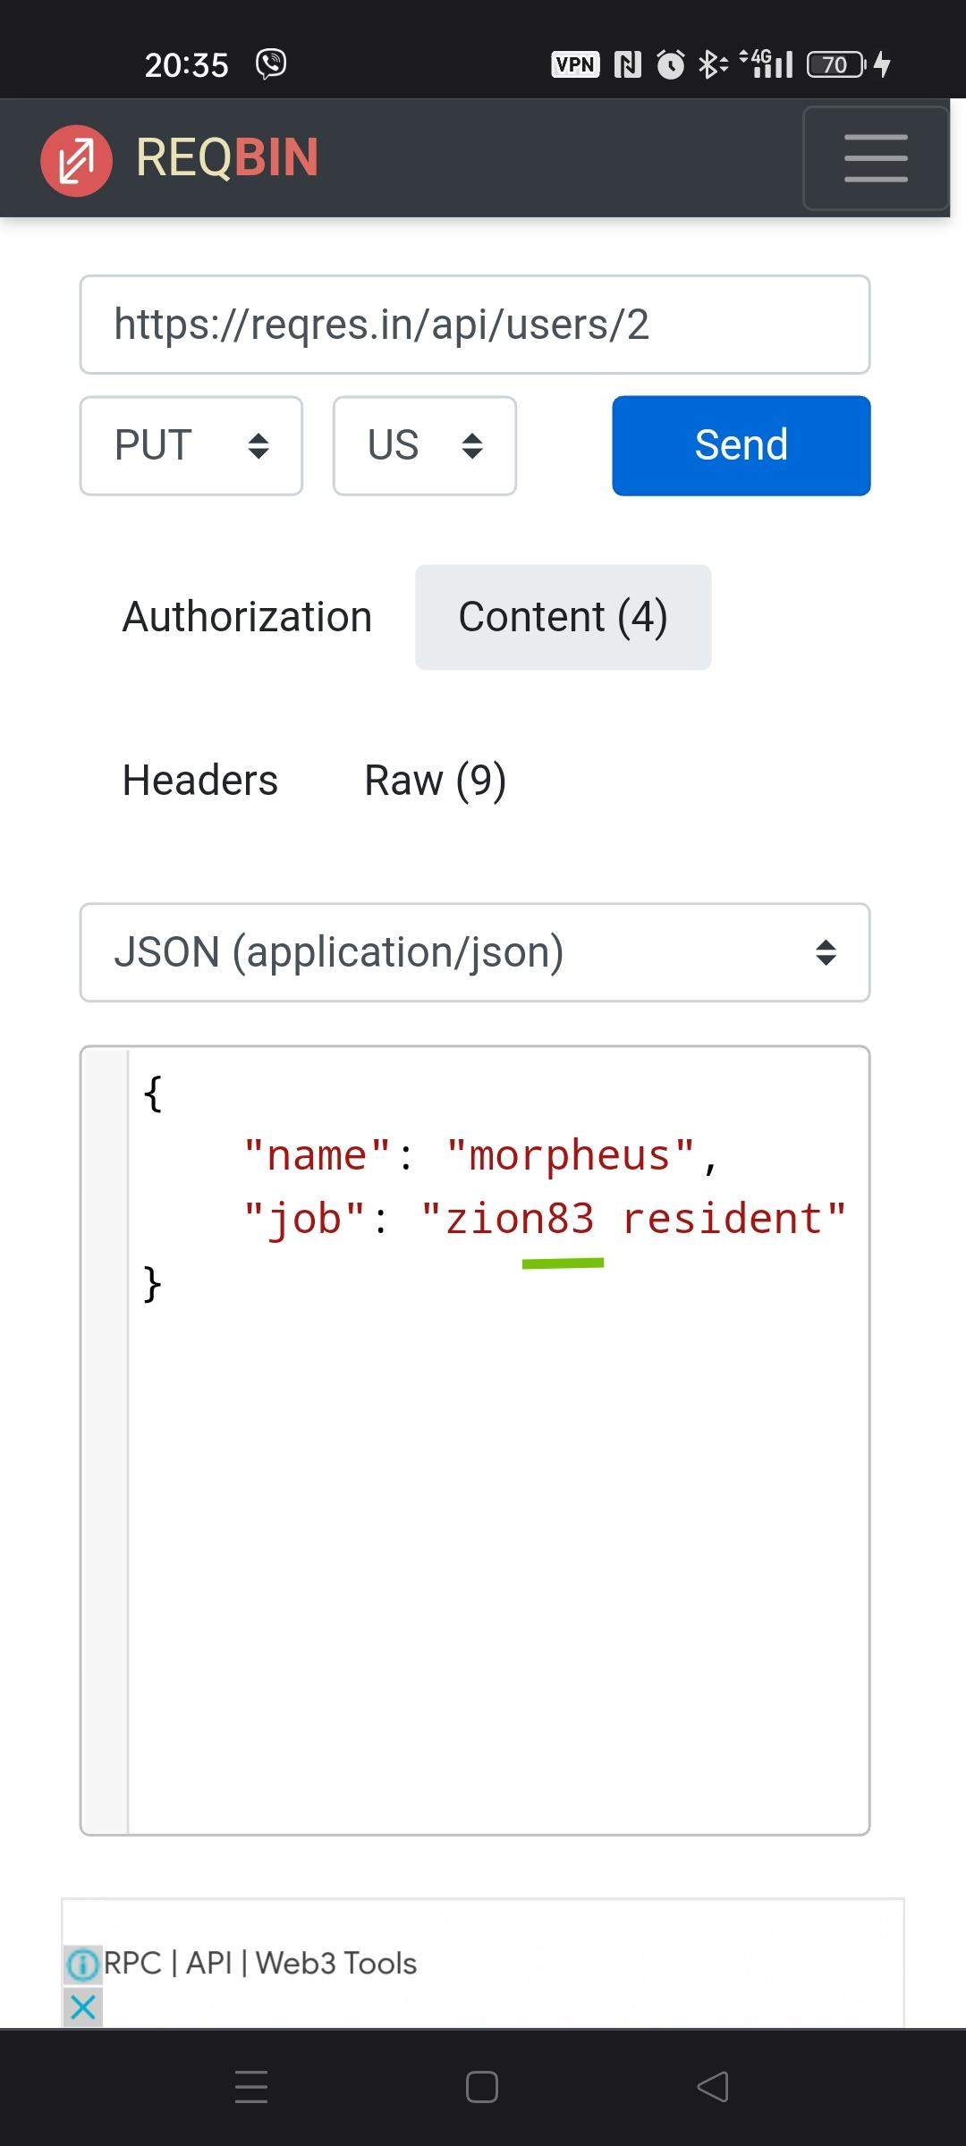

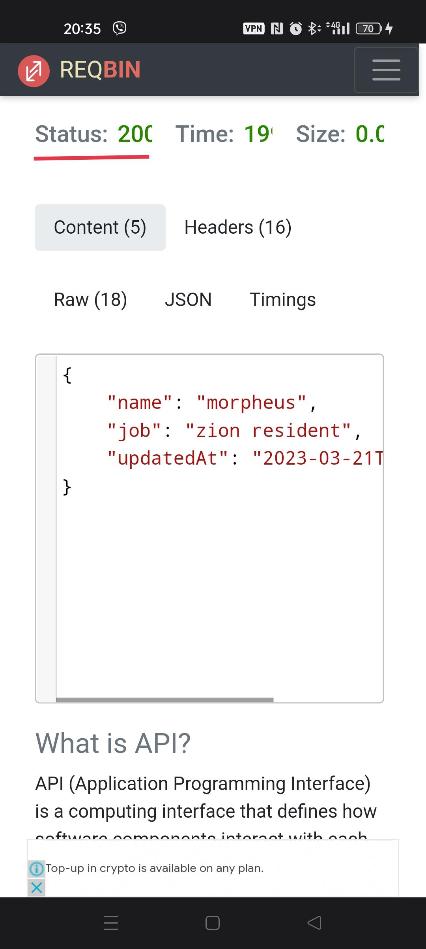

1. UPDATE (PATCH)

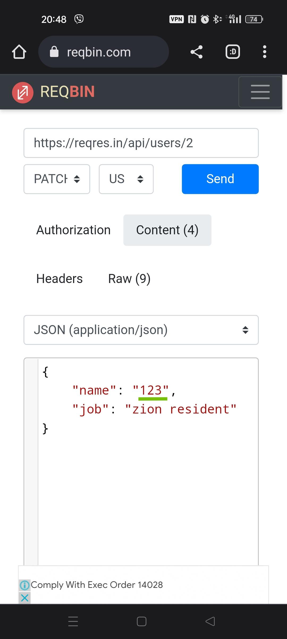

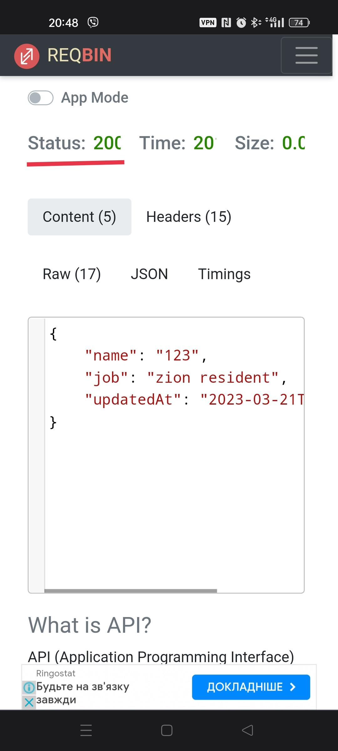

1. DELETE

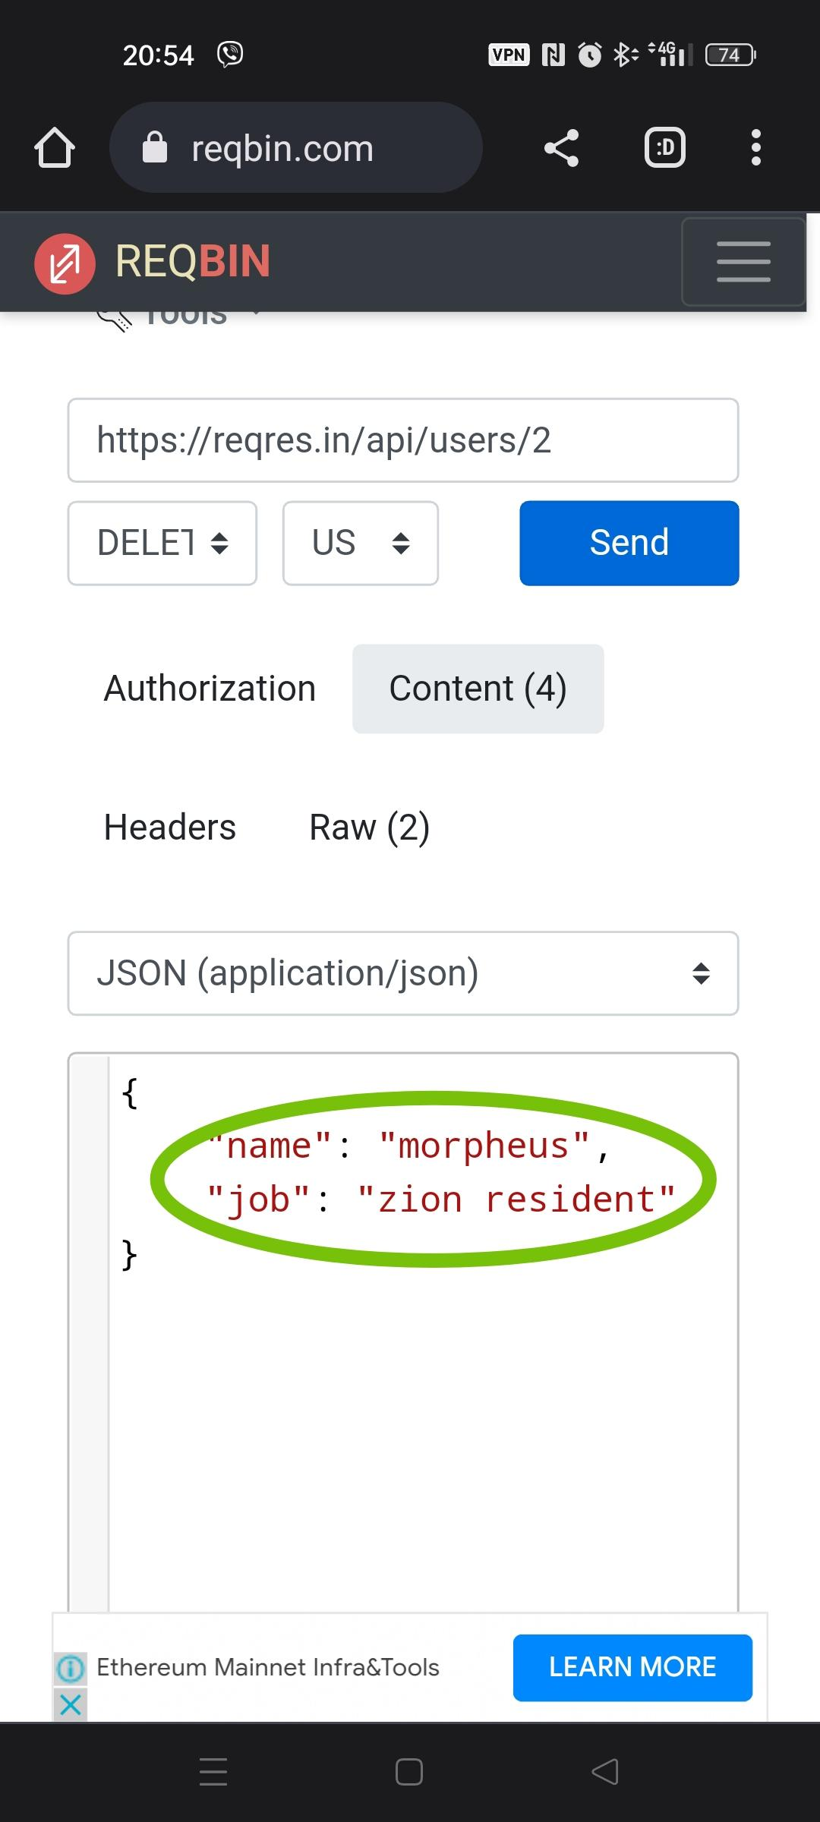

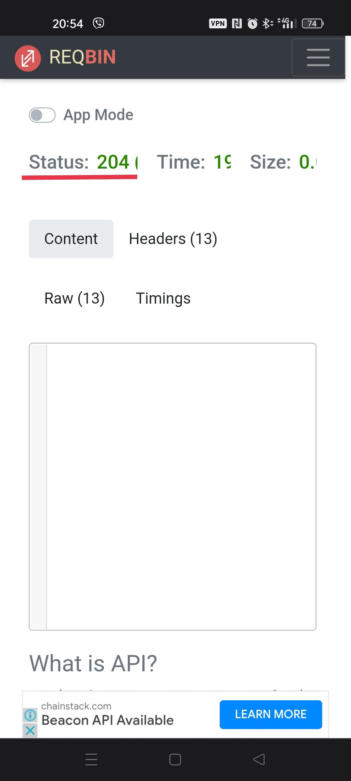

1. REGISTER - SUCCESSFUL (POST)

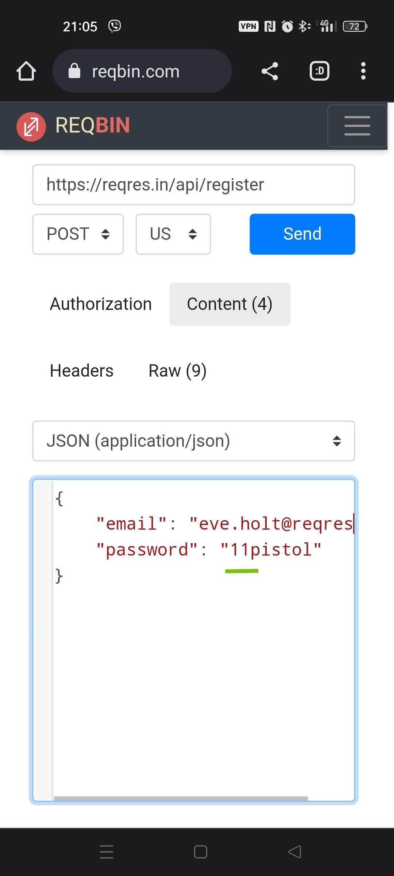

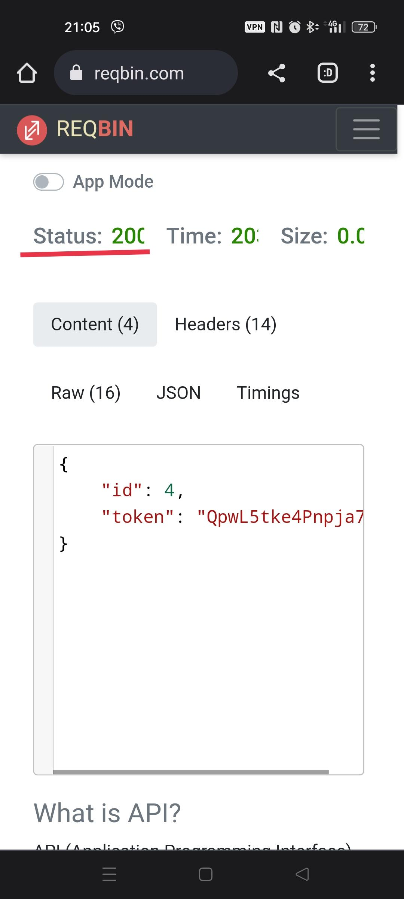

1. LOGIN - SUCCESSFUL (POST)

